Unit 12. Working With File Systems
What This Unit is About
This unit provides a more in-depth discussion on the structure and concepts of AIX
file systems.
What You Should Be Able To Do
After completing this unit, students should be able to:
- Identify the components of an AIX file system
- Add a journaled file system
- Change characteristics of a file system
How You Will Check Your Progress
Accountability:
- Checkpoint questions
- Exercises
References
- AIX Version 4.1 System Management Guide: Operating System and Devices SC23-2525
- AIX Storage Management Guide GG24-4484

12.1 Objectives
After completing this unit, students should be able to:
- Identify the components of an AIX file system
- Add a journaled file system
- Change characteristics of a file system
Notes:

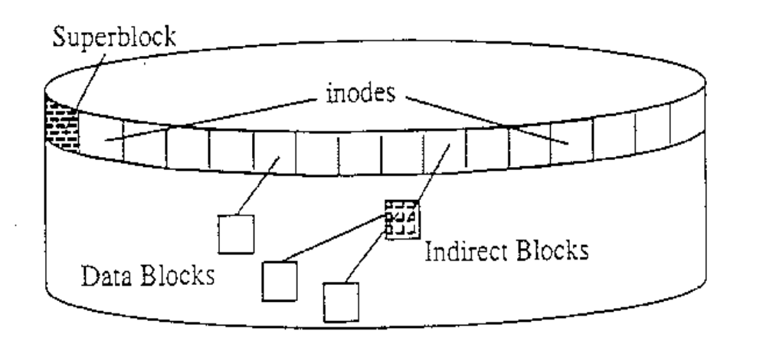12.2 Structure of a Journaled File System

12.2.1 Superblock
- File system size and identification
- Free list, fragment size, nbpi

12.2.2 Inodes
- File size, ownership, permissions, times
- Pointers to data blocks

12.2.3 Blocks
- Data blocks - contain data
- Indirect blocks-contain pointers to data blocks

Notes:
- An AIX journaled file system is built within a logical volume. The logical volume is divided into clusters of 4KB. This is the minimum unit of allocation. However, file system sizes are often referred to in terms of 512 byte blocks to remain compatible with other UNIX systems. (In. this description, when referring to a block we mean a 4KB cluster.) Of course, because a file system exists within a logical volume, its size will always be multiples of a logical partition (for example 4 MB).
- The first addressable block (cluster) on the file system is called the superblock and contains information which identifies that file system (for example name, size, number of inodes, date/time of creation) and the free list which will be explained later.
- Following the superblock are a fixed number of inodes, which contain the identifying information for files (for example type, size, permissions, user/group id of owner, date/time of creation / modification / last access). They also contain pointers to the data blocks which make up the files. Note: the inodes do not contain the file names, these are stored in the directory which those files belong to!
- The superblock is very important and a file system cannot be mounted if the superblock is corrupted. That is why there is a secondary superblock located at block 31 just in case it is needed for disaster recovery.

12.3 Structure of an inode
- Contents of an inode
- 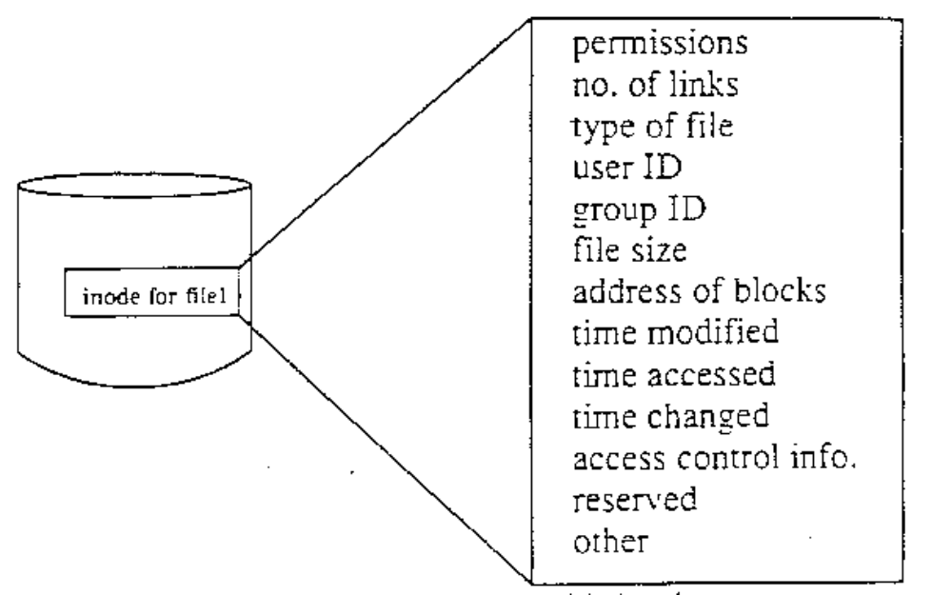This information can be seen with ls -1
$ ls -1 /home/team01
drwxr-xr-x 2 team01 staff 512 May 2 14:33 c
drwxr-xr-x 2 team01 staff 512 May 2 14:33 doc
-rw-r - -r - - 1 team01 staff 28 May 16 10:11 Manuals
-rw-r - -r - - 1 team0l staff 0 May 2 14:08 test1

Notes:
- Each file is represented by a single inode. The inode contains information about that file such as:
- ownership
- access permissions
- type
- creation, modification and access times
- no. of links to the file
- size
- addresses of data blocks on disk

12.4 Disk Fragmentation
4096 bytes
Before AIX Version 4
File size = 2000 bytes

this free space can not
be used by another file

2000 bytes
After AIX Version 4 4096 bytes
File size = 2000 bytes
Fragment size = 1024 bytes
1024 1024 1024 1024

these free fragment can
be used by other files

2000
bytes

Notes:
- Disk fragmentation provides a way to allocate pieces (or fragments) of a 4K logical block to files and directories. Fragment support is helpful for small user files and directories. Fragment support applies to the last direct block of small user files and directories and long symbolic links. Fragment size is specified for a file system at creation time. The allowable fragment size for JFS file systems are 512, 1024, 2048 and 4096 bytes. For consistency with AIX Version 3, the default fragment size is 4096 bytes.
- Different file systems can have different fragment sizes, but only one fragment size can be used within a single file system. Different fragment sizes can also coexist on a single system so that users can select a fragment size which is most appropriate for each file system.
- JFS fragment support provides a view of the file system as a contiguous series of fragments rather than disk blocks.
- Both operational overhead (additional disk seeks and allocation activity) and better utilization of disk space increase as the fragment size for a file system decreases. In order to maintain the optimum balance between increased overhead and increased usable disk space, the following factors apply to JFS fragment support:
- Disk space allocations of 4096 bytes of fragments are maintained for a file or directory's logical blocks where possible.
- Only partial logical blocks for files and directories less than 32KB in size can be allocated less than 4096 bytes of fragments.
- Although backup and restore sequences can be performed between file systems with different fragment sizes, due to increased disk utilization restore operations may fall because of a lack of free fragments.

12.5 Variable Number of Inodes
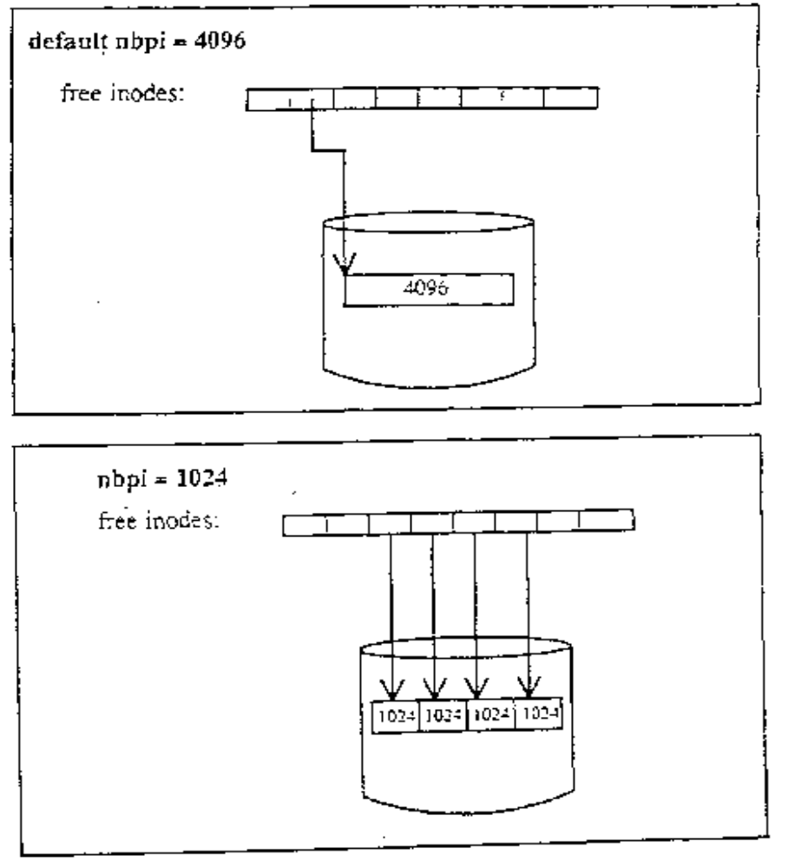Notes:
- In all UNIX implementations, when a file system is created, inodes are written to disk. For each file or directory one such data structure is used which describes information pertaining to the file or directory. AIX also reserves a number of inodes for files and directories in each file system that is created.
- In earlier versions of AIX, the number of inodes created for a file system was fixed. An inode was generated for every 4KB of disk space that was allocated to the file system being created. In a 4MB file system this would result in 1024 inodes being generated. As long as files and directories are allocated at a minimum of 4KB, this would suffice.
- However, since fragment support optimizes disk utilization, it increases the number of small files and directories that can be stored within a file system. Since each file or directory requires a disk inode, there needs to be a way to specify the number of inodes needed. The JFS allows the number of disk inodes created within a file system to be specified in case more or less than the default number of disk inodes is desired. This number can be specified at file system creation as the number of bytes per inode (NBPI). For example, an NBPI value of 1024 causes a disk inod-3 to be created for every 1024 bytes of file system space. A small NBPI values results in a large number of inodes and vice versa.

12.6 Maximum Sizes for Files and File systems
- AIX Version 4 file size limit 2GB
- AIX Version 4 file system size limit 256GB
Notes:
- The physical capacity of individual disk devices has exceeded 2GB. To make this capacity conveniently accessible to databases and other larger data file applications, the addressing constraint which limited the maximum size of a single file system to 2 GB had to be removed.
- Although the address limit has been increased, the maximum size of a file remains at 2 GS, whereas a file system may now theoretically be a maximum of 256 GB. Applications which directly access logical volumes may now be revised to access logical volumes beyond the 2 GB limit.

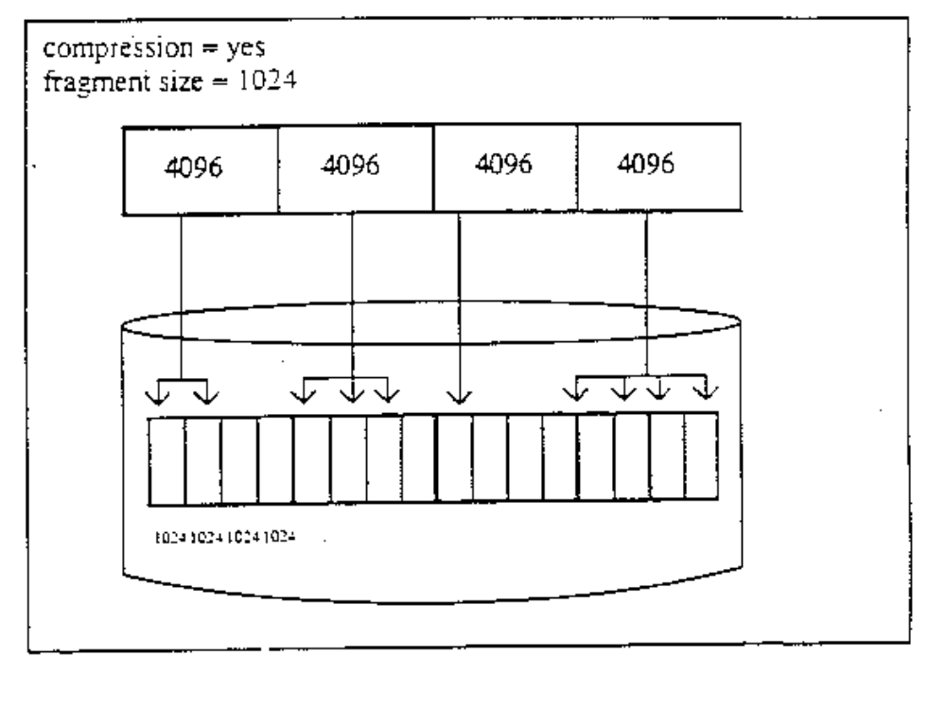12.7 Compressed File Systems
Notes:
- The AIX Version 4 JFS supports fragmented and compressed file systems. Both types of file systems save disk space by allowing a logical block to be stored on the disk in units or fragments smaller than the full block size of 4096 bytes. In a fragmented file system only the last logical block of files no larger than 32 KB are stored in this manner, so that fragment support is only beneficial for the file systems containing numerous small files. Data compression however, allows all logical blocks of any-sized file to be stored as one or more contiguous fragments. On average, data compression saves disk space by about a factor of 2.
- The use of fragments and data compression does, however, increase the potential for fragmentation of the disk's free space. Fragments allocated to a logical block must be contiguous on the disk. A file system experiencing free space fragmentation may have difficulty locating enough contiguous fragments for a logical block's allocation, even though the total number of free fragments may exceed the logical block's requirements. The AIX Version 4 JFS alleviates free space fragmentation by providing the defragfs utility which defragments file system by increasing the amount of contiguous space. This utility can used for fragmented and compressed file systems.
- Warning: the root file system must not be compressed.

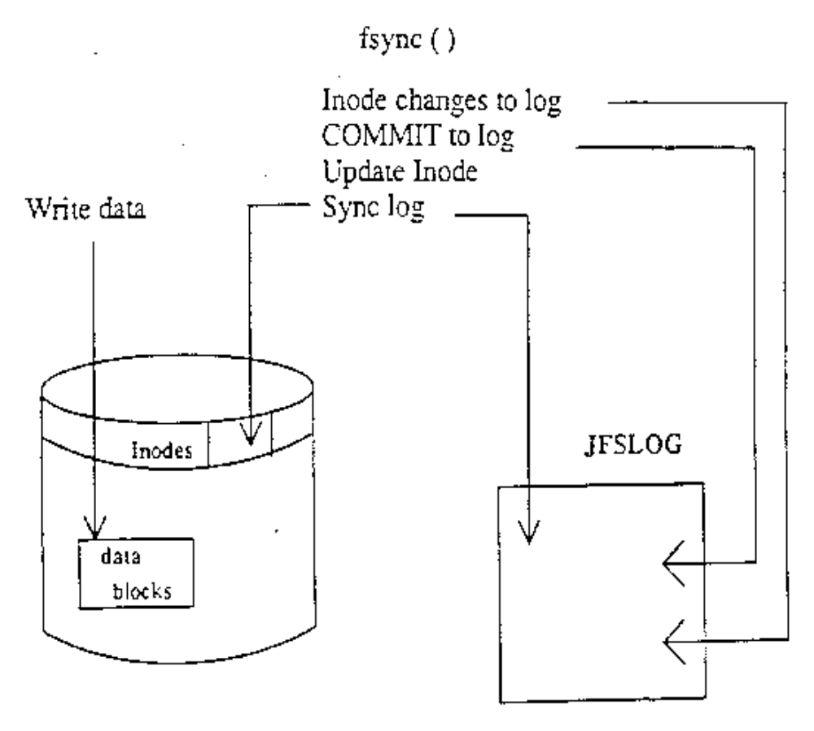12.8 Journaled Log
- No journaling of data blocks – only journals inode information (and indirect block information)
Notes:
- AIX memory maps files in current use. Any writes to files done first in memory and at a later stage are written out to disk when the sync system call runs - every minute.
- The jfslog (/dev/hd8) is a 4MB circular log. It is created the size of one physical partition -one per each volume group. The jfslog ensures file system integrity by writing all metadata information to the jfslog immediately. It does this in the form of transactions as illustrated in the diagram. File system metadata consists of changes to the structure itself such as changes to the inodes and the free list.
- When the data is written out to disk a sync point is indicated in the log and new transactions are written from that point forward.
- Metadata is information about the file system.

12.9 File Systems
# smit fs
File Systems

Move cursor to desired item and press Enter.

List All File Systems
List All Mounted File Systems
Add / Change / Show / Delete File Systems
Mount a File System
Mount a Group of File Systems
Unmount a File System
Unmount a Group of File Systems
Verify a File System
Backup a File System
Restore a File System
List Contents of a Backup

F1=Help F2=Refresh F3=Cancel Esc+8=Image
Esc+9=Shell Esc+0=Exit Enter=Do

Notes:

12.10 Listing File Systems
# lsfs
Name Nodename Mount Pt VFS Size Options Auto
/dev/hd4 — / jfs 8192 — yes
/dev/hd1 — /home jfs 90112 — yes
/dev/hd2 — /usr jfs 507904 — yes
/dev/hd9var — /var jfs 8192 — yes
/dev/hd3 — /tmp jfs 16384 — yes
/dev/cd0 — /infocd cdrfs ro yes
/dev/lv00 — /home/john jfs 8192 rw yes
Notes:
- You can list the various file systems that are defined using the lsfs command. This command will display information from /etc/filesystems and from the logical volumes in a more readable format.
- lsfs will also display information about CD-ROM file systems and remote NFS file systems.
- lsfs [-q] [-c |-l] [-v vfstype | mountgrp ] file system
- The data may be presented in line and colon (-c) or stanza (-l) format.
- It is possible to list only the file systems of a particular virtual file system type (-v), or within a particular mount group (-u). The -q option queries the superblock for the fragment size information, compression algorithm, and the number of bytes per inode.
- The SMIT fastpath to get to the screen which will accomplish the same task as the lsfs command is smit fs.

12.11 List All Mounted File Systems
# mount
node mounted mounted over vfs date options
/dev/hd4 / jfs Jul 11 20:14 rw.log=/dev/hd8
/dev/hd2 /usr jfs Jul 11 20:15 rw.log=/dev/hd8
/dev/hd9var /var jfs Jul 11 20:15 rw.log=/dev/hd8
/dev/hd3 /tmp jfs Jul 11 20:15 rw.log=/dev/hd8
/dev/hd1 /home jfs Jul 11 20:16 rw.log=/dev/hd8
/dev/lv00 /home/john jfs Jul 11 20:16 rw.log=/dev/hd8
Notes:
- The mount command, when used with no parameters, is used to list all the file systems which are currently mounted within the overall file system structure.
- File systems must be mounted to be accessed i.e. make the file system available for read and/or write access from your system
- The mount command when used with a number of parameters, is also used to perform the mount operation.
- There are two types of file systems, system created and user created. System created file systems are expected to be there by the system and by many applications. User created file systems contain user applications and data.
- Standard device names include:
- - hd4 /
- - hd1 /home
- - hd2 /usr
- - hd3 /tmp
- - hd9var /var
- SMIT can also be used to get this information. From SMIT you want to select List all Mounted File Systems, under File Systems.

12.12 Add a File System on a Previously Defined Logical Volume
# smit crjfslv
Add a File System on a Previously Defined Logical Volume

Type or select values in entry fields.
Press Enter AFTER making all desired changes.
[Entry Fields]
*LOGICAL VOLUME name +
*MOUNT POINT []
Mount AUTOMATICALLY at system restart? no +
PERMISSIONS read/write +
Mount OPTIONS [] +
Start Disk Accounting? no +
Fragment Size (bytes) 4096 +
Number of bytes per inode 4096 +
Compression algorithm no +

F1=Help F2=Refresh F3=Cancel F4=List
F5=Reset F6=Command F7=Edit F8=Image
F9=Shell F10=Exit Enter=Do

Notes:
- When a logical volume is created it is simply an empty container waiting to be formatted for use. The journaled file system is the most common way of using it. Thus, adding mats the logical volume for use a file system to a previously created logical volume for as a file system. Adding a file system in this way provides you with the greatest level of control over where the file system will reside on disk.

12.13Add a Journaled File System
# smit crjfs
Add a Journaled File System

Type or select values in entry fields.
Press Enter AFTER making all desired changes.
[Entry Fields]
Volume group name rootvg
*SIZE of file system(in 512-byte blocks) [ ] #
*MOUNT POINT [ ]
Mount AUTOMATICALLY at system restart? no +
PERMISSIONS read/write +
MOUNT OPTIONS [ ] +
Start Disk Accounting? no +
Fragment Size(bytes) 4096
Number of bytes per inode 4096
Compression algorithm no

F1=Help F2=Refresh F3=Cancel F4=List
F5=Reset F6=Command F7=Edit F8=Image
F9=Shell F10=Exit Enter=Do

Notes:
1. The crfs command is the high level command to create a file system.
- Note: Do not confuse the crfs command with the mkfs command which purely builds the file system structure within a logical volume. crfs does a lot more, it creates the logical volume if necessary using mklv, it builds the file system structure on that logical volume using mkfs, and then it makes all appropriate changes to the ODM and /etc/filesystems for that logical volume and file system.
- There are many parameters which can be set as a journaled file system is being created. The most important of these are given below:
- Volume group (-g volgrp); i.e., the volume group within which a new logical volume is to be created. The volume group must have sufficient free physical partitions for the new logical volume.
- The size (-a size=size) in 512 byte blocks. The size of the file system will be rounded up to the nearest logical partition boundary. This attribute specifies the minimum file system and can't be decreased dynamically after the file system has been successfully created.
- The mount point (-m mntpt). The name of a directory within the overall file system on which the new file system will normally be mounted. The mount point must exist before the file system can be mounted and accessed. Under most circumstances the mount point should be empty.
- A file system may be mounted at any other valid directory rather than its normal mount point. In this case, the mount is performed by the administrator, and it is usually for some type of maintenance activity.
- Automount? (-A yeslno). The new file system may be listed as automountable. This will place the mount = true line in the/etc/filesystems file and will cause the file system to be mounted automatically at its default mount point (above) when the system is restarted. If set to no then mount = false is added to the /etc/filesystems file.
- Permissions (-p rwlro). A mounted file system may be mounted in read-only (ro) or read-write (rw) mode. This permission setting will be used for the file system if it is mounted automatically, or if it is mounted without providing over-riding permissions.
- The permissions setting for a mounted file system may not be by-passed regardless of the authority of the user and the permission bits associated with the file or directory on the file system.
- Mount options specify security related mount options. Possible values are: nosuid which prevents the execution of setuid and setgid programs and nodev, which prevents open system calls of devices from this mount.
- The fragment size (-a fragment=size) specifies the JFS fragment size in bytes. A file system fragment is the smallest unit of disk storage that can be allocated to a file. This variable must be set to either 512, 1024, 2048 or 4096, the default value being 4096 bytes.
- The number of bytes per inode (-a nbpi=value) affects the total number of inodes on the file system. The variable must be either 512, 1024. 2048, 4096, 8192 or 16384, default value being 4096.
- The compression attribute (-a compress={no ︱LZ}) specifies the data compression algorithm LZ, which stands for the IBM version of the compression algorithm Lempel-Ziv. If you do not want data compression, set this attribute value to no, which is the default value.

12.14 Mount/Unmount a File System
#smit mountfs
Mount a File System
Type or select values in entry fields.
Press Enter AFTER making all desired changes.
[Entry Fields]
FILE SYSTEM name []
DIRECTORY over which to mount []
TYPE of file system
FORCE the mount? no
REMOTE NODE containing the file system
to mount []
Mount as a REMOVABLE file system? no
Mount as a READ-ONLY system? no
Disallow DEVICE access via this mount? no
Disallow execution of SUID and sgid programs no
in this file system?
F1=Help F2=Refresh F3=Cancel F4=List
F5=Reset F6=Command F7=Edit F8=Image
F9=Shell F10=Exit Enter=Do

Notes:
- The files within a file system can only be accessed when the file system is mounted within the overall file system structure.
- Either an individual file system or a group of file systems can be mounted.
- File systems defined with the mount=true or mount=automatic attribute in the /etc/filesystems file will be mounted automatically during system startup.
- The syntax of the mount and unmount commands are:
- mount [ -t Type︱Device︱Node: Directory] Directory
- # mount /home/liz/myfs
- umountlunmount [FileSystem︱-t Type]
- # unmount /home/liz/myfs
- File systems are usually mounted throughout the life of the system and are unmounted as part of the shutdown procedure.
- However the administrator or normal users may issue mount commands at any time, and assuming that the user has write permission to the mount point and read permission on the root directory of the file system to be mounted, the command will be effective.
- Normal users: can mount a file system provided they belong to the system group and have write access to the mount point
- System administrators: can mount a file system provided they have write access to the mount point and those mounts are specified in the /etc/filesystems file
- root: can mount anywhere under any set of permissions
- The mount command has many options which may be issued by the user. The default values for these options are set by the system, or are contained within /etc/filesystems.
- With the unmount command there are many other options that can be used other than -t Type or file system name.

12.15 Change / Show a Journaled File System
# smit chjfs
Change/Show Characteristics of a Journaled File System

Type or select values in entry fields.
Press Enter AFTER making all desired changes.

[Entry Fields]
File system name /home
NEW mount point [/home]
SIZE of file system (in 512-byte blocks) [8192]
Mount GROUP []
Mount AUTOMATICALLY at system restart? yes +
PERMISSIONS read/write +
Mount OPTIONS [] +
Start Disk Accounting? no +
Fragment Size (bytes) 4096
Number of bytes per inode 4096
Compression algorithm no

F1=Help F2=Refresh F3=Cancel F4=List
F5=Reset F6=Command F7=Edit F8=Image
F9=Shell F10=Exit Enter=Do

Notes:
- A Journaled File System may have its characteristics changed both while it is in use (mounted) and when it is not in use. To do this, use the chfs command.
- Many characteristics may be changed, the most important of these are:
- The mount point (-m mntpnt). The default mount point may be changed while the file system is in use but the change is only effective when the file system is next mounted.
- The size of a Journaled File System may be increased while it is in use (-a size=newsize). The size of a file system may not be decreased at any time, so it is often better to create a new file system and mount it at an appropriate point within the existing file system than to increase the size if it is suspected that the increased size is only temporarily required.
- Increasing the size of the file system extends the logical volume, so the new size will be rounded up to the next logical partition boundary. If you extend the logical volume directly, the partitions will be added, but the file system is not changed. Extending the file system will use those added partitions.
- The mount group of a file system may be changed (-u mntgrp), and the change will be effective the next time the new mount group is referenced.
- Automount ? Whether a file system is automatically mounted at system startup may be changed (-A yeslno) and the change will be effective at the next startup.
- The permissions associated with the file system may be chanced (-p rolrw) and the change will be effective the next time the file system is mounted.

12.16 Remove a Journaled File System
Remove a Journaled File System
Type or select values in entry fields.
Press Enter AFTER making all desired changes.
[Entry Fields]
File system name
Remove mount point no +

F1=Help F2=Refresh F3=Cancel F4=List
F5=Reset F6=Command F7=Edit F8=Image
F9=Shell F10=Exit Enter=Do

Notes:
- The rmfs command is the high level command used to remove a file system.
- In order to remove a file system, it must be unmounted from the overall file tree, and this cannot be done if the file system is in use i.e. some user or process is using the file system or has it as a current directory.
- rmfs will remove any information for the file system from the ODM and /etc/filesystems. When the file system is removed, the logical volume on which it resides is also removed.

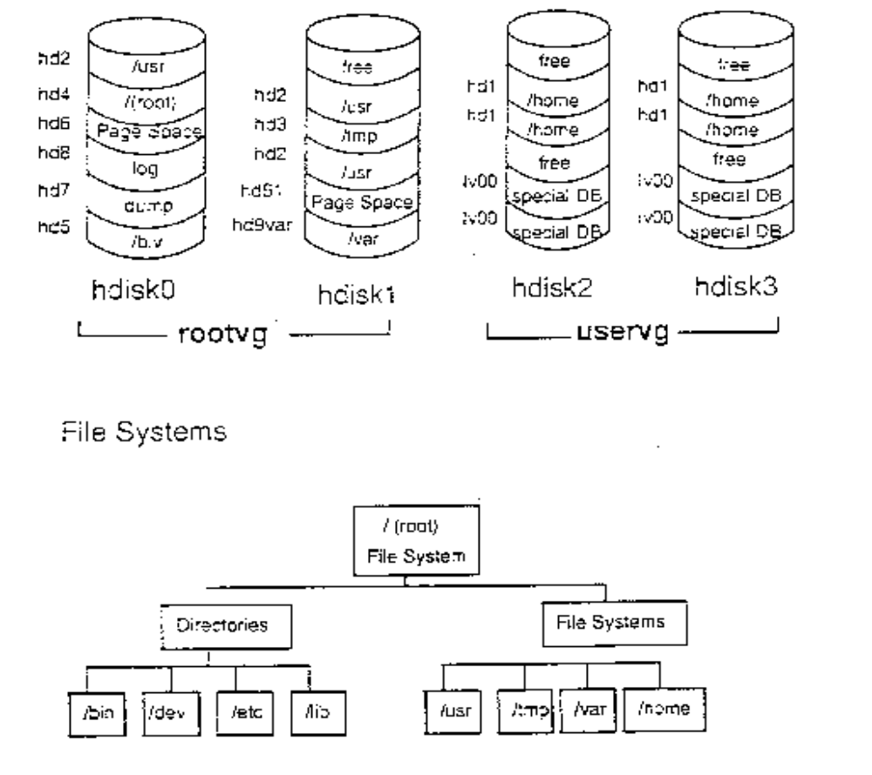12.17 System Storage Review
Logical Volume Structure
Notes:
- It is important to understand the difference between a file system and a directory. A file system is a section of disk that has been allocated to contain files. This section of disk is the logical volume. The section of disk is accessed by mounting the file system over a directory. Once the file system is mounted, it looks like any other directory structure to the user.
- The directories on the right of the bottom portion of the visual are all file systems. These file systems are all mounted on the directories /usr, /tmp, /var and /home. Notice the corresponding logical volume in the graphic at the top of the visual.
- The directories on the left of the bottom portion of the visual are strictly directories that contain files and are part of the /(root) file system.

12.18 Checkpoint
Exercise - File Systems
1. Will the size of the file system change when the size of the logical volume it is on is increased?
2. If a file system is the same size as the logical volume on which it sits, will the size of the logical volume increase when the size of the file system that is sitting on it increases?
3. If you remove a logical volume, will the file system that is sitting on it be removed as well?

12.19 Unit Summary
- The components of an AIX file system are the superblock, inodes, data blocks and indirect blocks
- File systems can be added and removed from the system, and their characteristics can also be changed, all through SMIT

